**World Quant University**

**Professor: Ivan Blanco**

**Alpha Design I**

Nikolas Lippmann Pareschi - [nikolaslippmann@gmail.com](mailto:nikolaslippmann@gmail.com)

**Mini Project: Unit 2**

1. Write a Python program to download the historical data of S&P500 over that period.

Code: 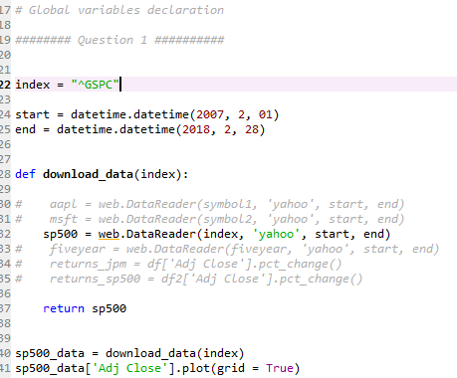

1. Show in a chart how the price of S&P 500 varied over that period. Plot Daily returns of the Index and identify periods of 5 worst historical monthly draw-downs.

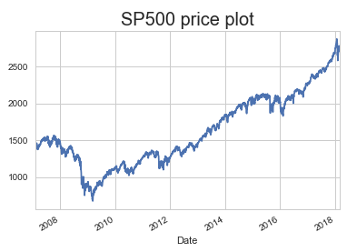

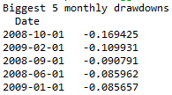

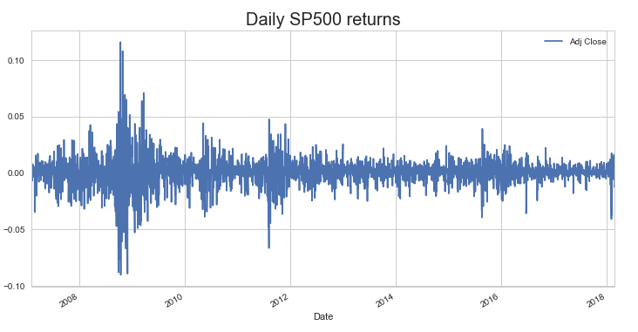

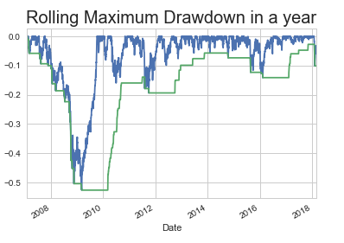

Code for question 2:

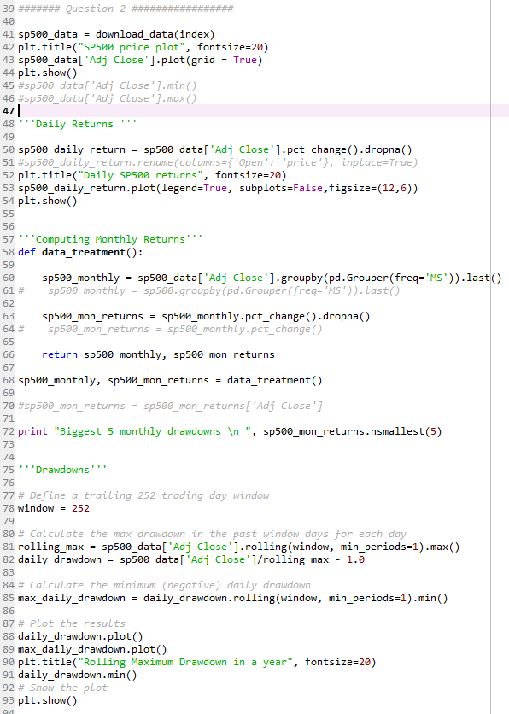

1. The Calmar Ratio is a drawdown related measure which equal to the compounded annual growth rate divided by the maximum drawdown.

                                                                       Img  
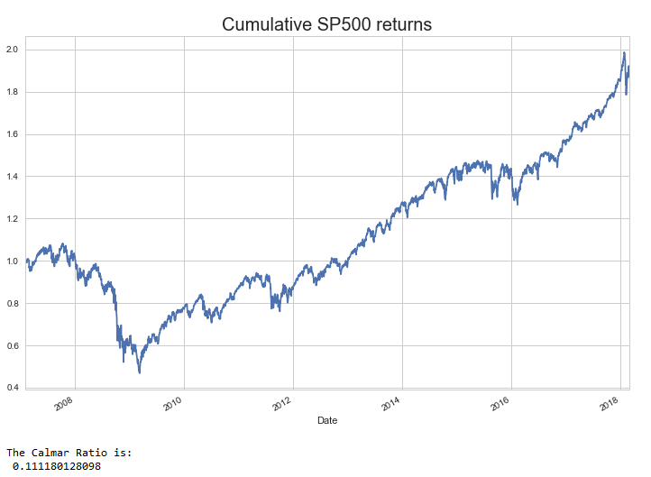

Code: 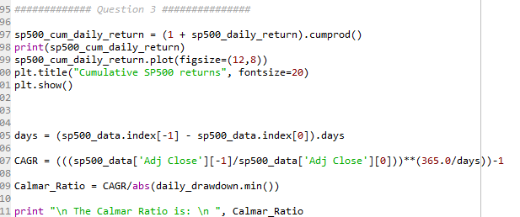

1. Consider a simple trading strategy where you invest 10,00 USD in the S&P500 every time the price closes above the 30 day moving average of daily close prices.
2. Graphically represent the return profile of this strategy.

Code:

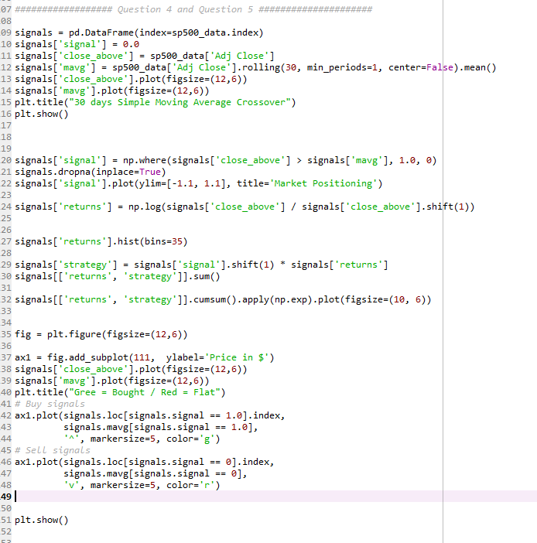

Results:

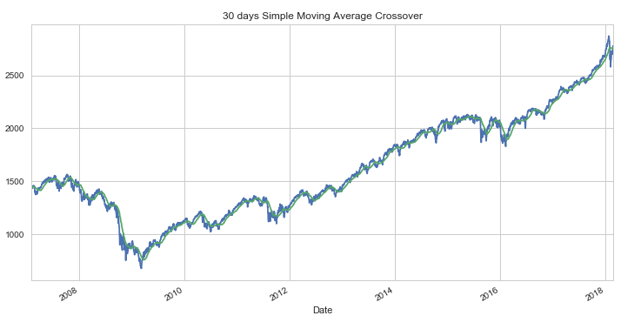

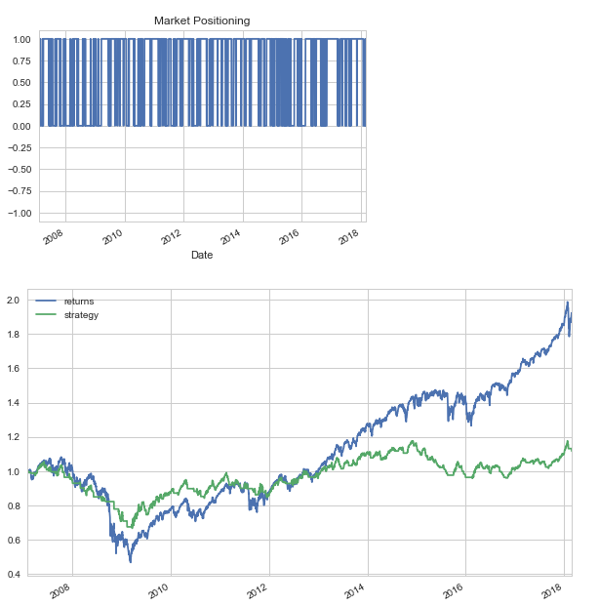

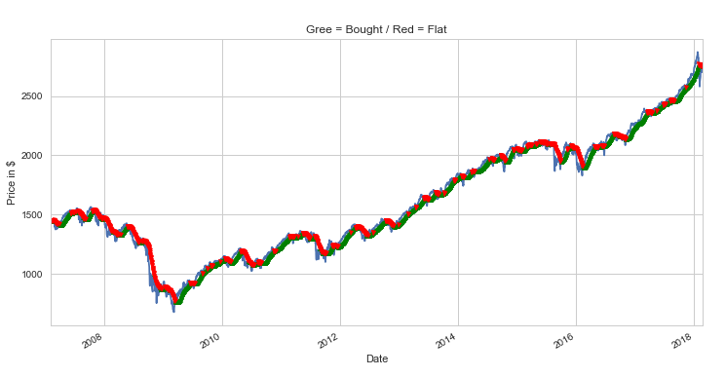

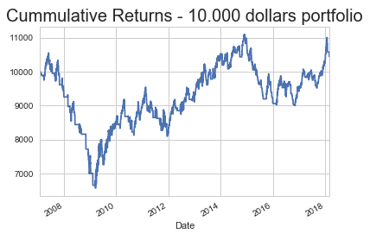

1. Calculate and graphically represent Lake Ratio & Gain to Pain ratio of such a strategy.

Code:

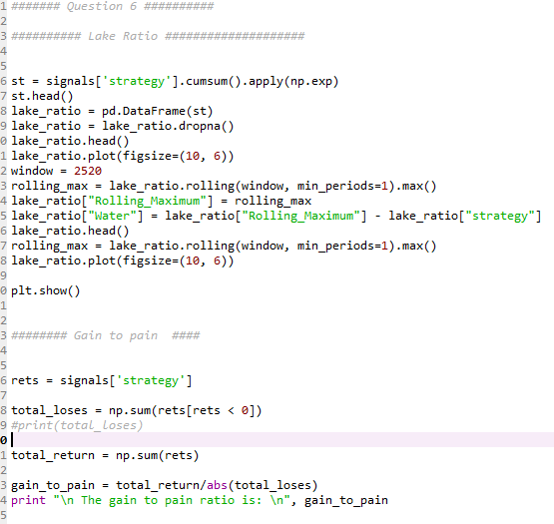

Results:

